File: Complex_dataset.csv
FirstName,LastName,DoB,DoJ,Address1,Address2,City,Pincode,Skill1,Skill2,Skill3,PayLevel,height,weight
Ritvik,Choudhry,31-12-1974,29-05-2016,"H.No. 24, Mani Marg",H.No. 44,Erode,503578,React,Java,Cloud,L4,5.5,78
Vihaan,Dara,22-04-1997,22-07-2016,"458
Sane Marg",52,Kottayam,572731,Data Science,React,Python,L1,5.3,84
Jayan,Iyengar,20-09-1981,15-01-2021,"72
Ghosh Marg",,Satna,412193,React,Java,Cloud,L4,5.4,56
Mehul,Chauhan,15-05-1968,12-11-2024,"H.No. 84
Chatterjee Chowk",,Madurai,694711,SQL,React,Cloud,L3,4.9,62
Hunar,Sunder,11-11-1977,03-02-2021,"445, Boase Circle",68,Hubli–Dharwad,686083,React,,Data Science,L1,4.4,58
Dhruv,Barad,06-12-1990,17-01-2018,"49/62, Choudhry Ganj",,Kottayam,474867,Python,,SQL,L1,4.7,75
Aarav,Rau,12-06-1969,10-10-2015,"H.No. 75, Ganesh Chowk",,Sambhal,402425,Data Science,React,Cloud,L2,5,45
Raunak,Sandal,11-01-1979,27-12-2020,"90/048, Joshi Street",H.No. 541,Solapur,751347,Data Science,Java,SQL,L4,4.2,32
Rohan,Garde,17-04-1975,18-04-2021,"40
Chandra Nagar",,Aizawl,245253,Java,Machine Learning,React,L4,5.3,69
Nehmat,Luthra,27-01-2022,28-05-1977,"H.No. 06, Chatterjee Marg",,Ambattur,,Cloud,Java,Data Science,L4,4.9,56
Hunar,Sura,20-09-1972,13-07-2023,"53, Seshadri Street",86,Durg,,Cloud,C++,React,L2,3.2,45
Ela,Lad,08-09-1989,11-11-2018,"033, Thaman Zila",,Jhansi,647254,React,Cloud,Java,L3,5.6,85
Ritvik,Varghese,03-03-1968,14-03-2022,"26, Bains Ganj",,Mehsana,938003,Java,,Python,L3,,74
Shamik,Shankar,30-03-1988,12-04-2018,"713, Barad Chowk",,Dhanbad,387712,C++,Python,Machine Learning,L3,4.11,48
Ahana ,Iyengar,10-08-1996,04-04-2018,"100
Chaudhry Chowk",,Ambala,795362,Machine Learning,Cloud,Python,L1,4.6,95
Hansh,Khare,12-03-1984,16-07-2021,"28/10, Sani Circle",31/127,Hazaribagh,686651,Cloud,Data Science,SQL,L4,,67
Tarini,Dua,12-06-1973,03-12-2017,"H.No. 40, Bail Ganj",,Ghaziabad,542354,Cloud,Java,Machine Learning,L3,,74
Tara,Shetty,16-04-1966,03-12-2020,"56/66
Ratta Road",34,Bharatpur,182431,SQL,C++,Data Science,L2,5.3,72
Indrans,Sibal,22-08-2003,29-07-2024,"82, Loke",,Dhanbad,735783,Cloud,Python,Machine Learning,L2,,81
Pari,Edwin,10-05-2024,15-07-1974,"H.No. 867, Varkey Road",,Bijapur,187813,React,Cloud,Python,L1,4.2,52
Devansh,Shroff,29-03-1985,06-10-2015,"H.No. 490, Sem Path",,Indore,203852,React,Java,Cloud,L1,,43
Priyansh,Sabharwal,14-04-1983,05-10-2022,"06
Mannan",,Indore,132151,C++,React,Cloud,L3,6.2,
Shray,Sami,20-12-1972,23-04-2022,"52
Ghose Ganj",H.No. 27,Hindupur,333303,Python,React,Java,L2,,54
Tanya,Sha,01-10-1978,09-03-2019,"H.No. 94, Chaudhuri Chowk",43/04,Durg,897692,SQL,Java,Cloud,L1,,53
Ishita,Ravel,09-03-1967,07-04-2020,"391, Dixit Ganj",54,Imphal,996400,C++,React,Machine Learning,L3,5.9,62
Trisha,Brar,27-10-1966,02-05-2023,"98, Chhabra Chowk",,Jamnagar,029817,Python,Java,Data Science,L3,,
Onkar,Kothari,10-05-1999,21-12-2023,"H.No. 094, Zacharia Chowk",692,Firozabad,531274,Java,React,C++,L3,5,45
Shaan,Mallick,01-01-1983,03-06-2024,"352
Dass Zila",,Bahraich,763443,Python,React,Data Science,L2,,12
Riya,Gara,23-12-2000,09-07-2018,"156
Apte Road",,Thrissur,492241,Python,Java,Cloud,L2,4.1,94
Hrishita,Sastry,01-02-1971,21-10-2015,"H.No. 322
Choudhury Road",,Ramagundam,544151,SQL,Cloud,Python,L3,5.9,56
Anahita,Vala,11-12-1978,13-06-2021,"24
Khalsa Street",597,Howrah,077654,Data Science,Python,Cloud,L2,,45
Neelofar,Choudhury,30-10-1967,02-07-2019,"H.No. 74, Randhawa Road",892,Phagwara,768067,SQL,Python,C++,L3,,78
Hridaan,Borra,01-08-1977,27-09-2024,"525
Dugar Path",H.No. 914,Nagpur,048268,Cloud,Data Science,Machine Learning,L2,,16
Charvi,Krishnamurthy,26-11-1982,03-03-2017,"17/414, Khatri Path",H.No. 88,Nagpur,970104,React,Machine Learning,SQL,L4,5.5,51
Hansh,Savant,08-03-2003,30-10-2017,"H.No. 88
Barman Ganj",H.No. 73,Guna,970465,React,Machine Learning,C++,L3,5.3,65
Yasmin,Sarna,22-01-1966,15-09-2022,"509, Srinivasan Zila",49/604,Agartala,537332,Machine Learning,C++,Java,L2,5.4,
Yuvaan,Chawla,10-06-1965,11-10-2021,"44
Kakar Street",58,Tirunelveli,257842,SQL,Python,Data Science,L2,4.9,25
Anahita,Vala,11-12-1978,13-06-2021,"24
Khalsa Street",597,Howrah,077654,Data Science,Python,Cloud,L2,4.4,45
Anya,Chahal,29-10-1984,22-06-2019,"H.No. 669, Singhal Chowk",19/345,Surendranagar Dudhrej,288768,Machine Learning,React,Java,L2,4.7,69
Nayantara,Kohli,25-11-1992,19-04-2024,"53/83
Bumb Chowk",,Solapur,148762,Machine Learning,Data Science,Python,L2,5,
Samaira,Gopal,25-11-1984,05-08-2019,"H.No. 32
Lall Circle",,Adoni,,React,Python,Data Science,L4,4.2,57
Raunak,Vohra,05-05-2001,02-08-2016,"H.No. 630, Bajaj Zila",,Machilipatnam,534145,SQL,React,C++,L1,5.3,35
Tara,Shetty,16-04-1966,03-12-2020,"56/66
Ratta Road",34,Bharatpur,,SQL,C++,Data Science,L2,4.9,85
Charvi,Krishnamurthy,26-11-1982,03-03-2017,"17/414, Khatri Path",H.No. 88,Nagpur,970104,React,Machine Learning,SQL,L4,3.2,
Samar,Vig,30-07-1977,24-12-2023,"64/610
Divan Nagar",,Avadi,,C++,Java,React,L3,5.6,78
Tarini,Balakrishnan,18-12-1996,26-03-2017,"37/564, Kar Nagar",,Erode,021891,Machine Learning,SQL,C++,L4,,65
Aayush,Trivedi,29-06-1973,23-04-2022,"79/838, Sen Street",H.No. 141,Bhilai,548617,Cloud,SQL,React,L4,4.8,54
Shamik,Shankar,30-03-1988,12-04-2018,"713, Barad Chowk",,Dhanbad,,C++,Python,Machine Learning,L3,,59
Nitya,Krishnan,06-08-1967,05-07-2019,"19/15
Dasgupta Nagar",,Dehradun,576585,SQL,Java,C++,L2,,45
Rasha,Bhargava,07-05-1967,02-05-2022,"H.No. 17, Gandhi Marg",H.No. 509,Rajpur Sonarpur,063196,Python,C++,Java,L4,4.9,
Yuvaan,Chawla,10-06-1965,11-10-2021,"44
Kakar Street",58,Tirunelveli,257842,SQL,,Data Science,L2,4.3,26
Adira,Saran,29-08-1992,29-07-2018,"H.No. 67
Apte Marg",Nov-72,Hajipur,741730,Python,Machine Learning,C++,L3,5.1,57
Sumer,Desai,18-05-1997,01-05-2024,"37/057
Majumdar Ganj",,Tirunelveli,238231,Cloud,,React,L2,5.3,54
Sana,Bahri,24-06-1972,26-01-2019,"78/344
Khalsa Street",,Bally,494759,React,,Java,L1,4.1,56
Inaaya ,Deol,26-09-1980,23-08-2021,"H.No. 32, Lad",88,Jaipur,882546,Java,Cloud,SQL,L4,5.2,67

CODE:
import pandas as pd
import numpy as np
import warnings
warnings.simplefilter(action='ignore', category=FutureWarning)
# Load CSV with na_values to catch 'Nan' strings as NaN
df = pd.read_csv("Complex_dataset.csv", na_values=["Nan"])
print(df.head())
print(df.info())
print("Initial shape:", df.shape)
# Clean and standardize City names before using them
df["City"] = df["City"].astype(str).str.strip().str.title()
# Parse dates, day first format, coerce errors
df["DoB"] = pd.to_datetime(df["DoB"], errors="coerce", dayfirst=True)
df["DoJ"] = pd.to_datetime(df["DoJ"], errors="coerce", dayfirst=True)
today = pd.to_datetime("today")
df.loc[df["DoB"] > today, "DoB"] = np.nan
df.loc[df["DoJ"] > today, "DoJ"] = np.nan
# Clean Address fields: remove \n and strip whitespace
df["Address1"] = df["Address1"].astype(str).str.replace("\n", " ", regex=True).str.strip()
df["Address2"] = df["Address2"].astype(str).str.replace("\n", " ", regex=True).str.strip()
# Fill empty Address2 with 'N/A'
df["Address2"] = df["Address2"].replace({"nan": np.nan, "": np.nan})
df["Address2"] = df["Address2"].fillna("N/A")
# Function to add 'H.No.' prefix if address is just digits
def add_hno_prefix(addr):
if pd.isna(addr) or addr == "" or addr == "N/A":
return addr
addr_stripped = addr.strip()
if addr_stripped.isdigit():
return "H.No. " + addr_stripped
else:
return addr
df["Address1"] = df["Address1"].apply(add_hno_prefix)
df["Address2"] = df["Address2"].apply(add_hno_prefix)
# Move Address2 to Address1 if Address1 is empty, then set Address2 to 'N/A'
def move_address(row):
addr1 = row["Address1"]
addr2 = row["Address2"]
if (pd.isna(addr1) or addr1 == "" or addr1 == "N/A") and (addr2 and addr2 != "N/A"):
row["Address1"] = addr2
row["Address2"] = "N/A"
return row
df = df.apply(move_address, axis=1)
# Impute missing Pincode by most common Pincode per City
city_pincode_map = df.groupby("City")["Pincode"].agg(lambda x: x.mode().iloc[0] if not x.mode().empty else np.nan)
def impute_pincode(row):
if pd.isna(row["Pincode"]) or str(row["Pincode"]).strip() == "":
return city_pincode_map.get(row["City"], np.nan)
else:
return row["Pincode"]
df["Pincode"] = df.apply(impute_pincode, axis=1)
# Convert Pincode to int if possible, else keep NaN
df["Pincode"] = pd.to_numeric(df["Pincode"], errors="coerce").astype('Int64')
# Clean Skill columns: strip and title case
for col in ["Skill1", "Skill2", "Skill3"]:
df[col] = df[col].astype(str).str.strip().str.title()
# Replace 'Nan' strings that might remain
df[col] = df[col].replace("Nan", np.nan)
# Fix Skill2 if missing but Skill1 and Skill3 exist
mask = (df["Skill1"].notna()) & (df["Skill3"].notna()) & (df["Skill2"].isna())
print(f"Number of Skill2 values to be replaced from Skill3: {mask.sum()}")
df.loc[mask, "Skill2"] = df.loc[mask, "Skill3"]
df.loc[mask, "Skill3"] = np.nan
# Fill missing height and weight with mean
df["height"] = pd.to_numeric(df["height"], errors="coerce")
df["weight"] = pd.to_numeric(df["weight"], errors="coerce")
df["height"] = df["height"].fillna(df["height"].mean()).round(2)
df["weight"] = df["weight"].fillna(df["weight"].mean()).round(1)
# Clean PayLevel and create a numeric order column
df["PayLevel"] = df["PayLevel"].astype(str).str.upper().str.strip()
pay_order = {"L1": 1, "L2": 2, "L3": 3, "L4": 4}
df["PayOrder"] = df["PayLevel"].map(pay_order)
# Handle duplicates by averaging height & weight, taking first skill values and PayLevel,
# grouping by all other columns except skills, height, weight
exclude_cols = ['Skill1', 'Skill2', 'Skill3', 'height', 'weight', 'PayLevel']
cols_to_group = [col for col in df.columns if col not in exclude_cols]
df_grouped = df.groupby(cols_to_group, dropna=False).agg({
'height': 'mean',
'weight': 'mean',
'Skill1': 'first',
'Skill2': 'first',
'Skill3': 'first',
'PayLevel': 'first'
}).reset_index()
df = df_grouped.copy()
# Sort by PayOrder
df = df.sort_values(by="PayOrder").reset_index(drop=True)
# Drop PayOrder helper column
df.drop(columns=["PayOrder"], inplace=True)
print("\nCleaned DataFrame shape:", df.shape)
print(df.head())
# Save cleaned dataset
df.to_csv("Complex_dataset_cleaned_.csv", index=False)
OUTPUT:
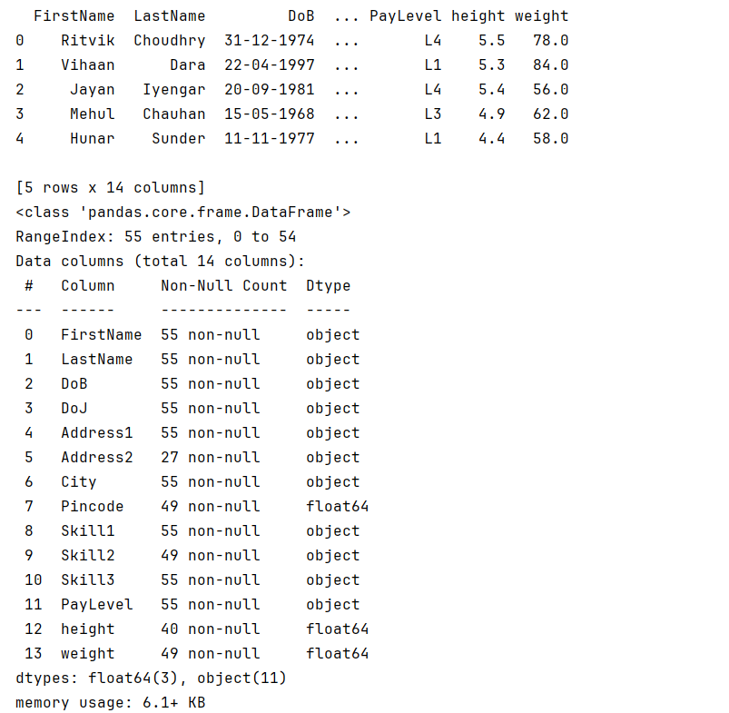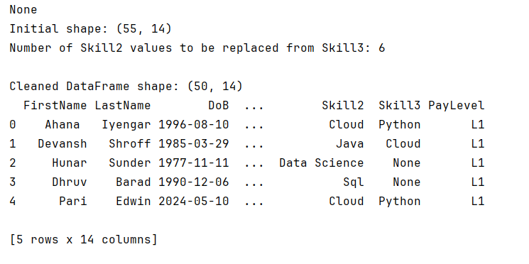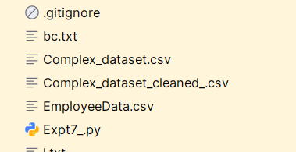
File: Complex_dataset_cleaned_.csv
FirstName,LastName,DoB,DoJ,Address1,Address2,City,Pincode,height,weight,Skill1,Skill2,Skill3,PayLevel
Ahana ,Iyengar,10-08-1996,04-04-2018,100 Chaudhry Chowk,N/A,Ambala,795362,4.6,95,Machine Learning,Cloud,Python,L1
Devansh,Shroff,29-03-1985,06-10-2015,"H.No. 490, Sem Path",N/A,Indore,203852,4.9,43,React,Java,Cloud,L1
Hunar,Sunder,11-11-1977,03-02-2021,"445, Boase Circle",H.No. 68,Hubli–Dharwad,686083,4.4,58,React,Data Science,,L1
Dhruv,Barad,06-12-1990,17-01-2018,"49/62, Choudhry Ganj",N/A,Kottayam,474867,4.7,75,Python,Sql,,L1
Pari,Edwin,10-05-2024,15-07-1974,"H.No. 867, Varkey Road",N/A,Bijapur,187813,4.2,52,React,Cloud,Python,L1
Raunak,Vohra,05-05-2001,02-08-2016,"H.No. 630, Bajaj Zila",N/A,Machilipatnam,534145,5.3,35,Sql,React,C++,L1
Tanya,Sha,01-10-1978,09-03-2019,"H.No. 94, Chaudhuri Chowk",43/04,Durg,897692,4.9,53,Sql,Java,Cloud,L1
Sana,Bahri,24-06-1972,26-01-2019,78/344 Khalsa Street,N/A,Bally,494759,4.1,56,React,Java,,L1
Vihaan,Dara,22-04-1997,22-07-2016,458 Sane Marg,H.No. 52,Kottayam,572731,5.3,84,Data Science,React,Python,L1
Hunar,Sura,20-09-1972,13-07-2023,"53, Seshadri Street",H.No. 86,Durg,897692,3.2,45,Cloud,C++,React,L2
Anahita,Vala,11-12-1978,13-06-2021,24 Khalsa Street,H.No. 597,Howrah,77654,4.65,45,Data Science,Python,Cloud,L2
Nitya,Krishnan,06-08-1967,05-07-2019,19/15 Dasgupta Nagar,N/A,Dehradun,576585,4.9,45,Sql,Java,C++,L2
Nayantara,Kohli,25-11-1992,19-04-2024,53/83 Bumb Chowk,N/A,Solapur,148762,5,58.3,Machine Learning,Data Science,Python,L2
Indrans,Sibal,22-08-2003,29-07-2024,"82, Loke",N/A,Dhanbad,735783,4.9,81,Cloud,Python,Machine Learning,L2
Anya,Chahal,29-10-1984,22-06-2019,"H.No. 669, Singhal Chowk",19/345,Surendranagar Dudhrej,288768,4.7,69,Machine Learning,React,Java,L2
Hridaan,Borra,01-08-1977,27-09-2024,525 Dugar Path,H.No. 914,Nagpur,48268,4.9,16,Cloud,Data Science,Machine Learning,L2
Tara,Shetty,16-04-1966,03-12-2020,56/66 Ratta Road,H.No. 34,Bharatpur,182431,5.1,78.5,Sql,C++,Data Science,L2
Shaan,Mallick,01-01-1983,03-06-2024,352 Dass Zila,N/A,Bahraich,763443,4.9,12,Python,React,Data Science,L2
Sumer,Desai,18-05-1997,01-05-2024,37/057 Majumdar Ganj,N/A,Tirunelveli,238231,5.3,54,Cloud,React,,L2
Shray,Sami,20-12-1972,23-04-2022,52 Ghose Ganj,H.No. 27,Hindupur,333303,4.9,54,Python,React,Java,L2
Riya,Gara,23-12-2000,09-07-2018,156 Apte Road,N/A,Thrissur,492241,4.1,94,Python,Java,Cloud,L2
Aarav,Rau,12-06-1969,10-10-2015,"H.No. 75, Ganesh Chowk",N/A,Sambhal,402425,5,45,Data Science,React,Cloud,L2
Yasmin,Sarna,22-01-1966,15-09-2022,"509, Srinivasan Zila",49/604,Agartala,537332,5.4,58.3,Machine Learning,C++,Java,L2
Yuvaan,Chawla,10-06-1965,11-10-2021,44 Kakar Street,H.No. 58,Tirunelveli,257842,4.6,25.5,Sql,Python,Data Science,L2
Priyansh,Sabharwal,14-04-1983,05-10-2022,06 Mannan,N/A,Indore,132151,6.2,58.3,C++,React,Cloud,L3
Onkar,Kothari,10-05-1999,21-12-2023,"H.No. 094, Zacharia Chowk",H.No. 692,Firozabad,531274,5,45,Java,React,C++,L3
Mehul,Chauhan,15-05-1968,12-11-2024,H.No. 84 Chatterjee Chowk,N/A,Madurai,694711,4.9,62,Sql,React,Cloud,L3
Hrishita,Sastry,01-02-1971,21-10-2015,H.No. 322 Choudhury Road,N/A,Ramagundam,544151,5.9,56,Sql,Cloud,Python,L3
Hansh,Savant,08-03-2003,30-10-2017,H.No. 88 Barman Ganj,H.No. 73,Guna,970465,5.3,65,React,Machine Learning,C++,L3
Neelofar,Choudhury,30-10-1967,02-07-2019,"H.No. 74, Randhawa Road",H.No. 892,Phagwara,768067,4.9,78,Sql,Python,C++,L3
Adira,Saran,29-08-1992,29-07-2018,H.No. 67 Apte Marg,Nov-72,Hajipur,741730,5.1,57,Python,Machine Learning,C++,L3
Ela,Lad,08-09-1989,11-11-2018,"033, Thaman Zila",N/A,Jhansi,647254,5.6,85,React,Cloud,Java,L3
Trisha,Brar,27-10-1966,02-05-2023,"98, Chhabra Chowk",N/A,Jamnagar,29817,4.9,58.3,Python,Java,Data Science,L3
Ishita,Ravel,09-03-1967,07-04-2020,"391, Dixit Ganj",H.No. 54,Imphal,996400,5.9,62,C++,React,Machine Learning,L3
Ritvik,Varghese,03-03-1968,14-03-2022,"26, Bains Ganj",N/A,Mehsana,938003,4.9,74,Java,Python,,L3
Tarini,Dua,12-06-1973,03-12-2017,"H.No. 40, Bail Ganj",N/A,Ghaziabad,542354,4.9,74,Cloud,Java,Machine Learning,L3
Shamik,Shankar,30-03-1988,12-04-2018,"713, Barad Chowk",N/A,Dhanbad,387712,4.505000000000001,53.5,C++,Python,Machine Learning,L3
Samar,Vig,30-07-1977,24-12-2023,64/610 Divan Nagar,N/A,Avadi,111111,5.6,78,C++,Java,React,L3
Ritvik,Choudhry,31-12-1974,29-05-2016,"H.No. 24, Mani Marg",H.No. 44,Erode,503578,5.5,78,React,Java,Cloud,L4
Hansh,Khare,12-03-1984,16-07-2021,"28/10, Sani Circle",31/127,Hazaribagh,686651,4.9,67,Cloud,Data Science,Sql,L4
Aayush,Trivedi,29-06-1973,23-04-2022,"79/838, Sen Street",H.No. 141,Bhilai,548617,4.8,54,Cloud,Sql,React,L4
Raunak,Sandal,11-01-1979,27-12-2020,"90/048, Joshi Street",H.No. 541,Solapur,751347,4.2,32,Data Science,Java,Sql,L4
Rasha,Bhargava,07-05-1967,02-05-2022,"H.No. 17, Gandhi Marg",H.No. 509,Rajpur Sonarpur,63196,4.9,58.3,Python,C++,Java,L4
Nehmat,Luthra,27-01-2022,28-05-1977,"H.No. 06, Chatterjee Marg",N/A,Ambattur,222222,4.9,56,Cloud,Java,Data Science,L4
Jayan,Iyengar,20-09-1981,15-01-2021,72 Ghosh Marg,N/A,Satna,412193,5.4,56,React,Java,Cloud,L4
Inaaya ,Deol,26-09-1980,23-08-2021,"H.No. 32, Lad",H.No. 88,Jaipur,882546,5.2,67,Java,Cloud,Sql,L4
Charvi,Krishnamurthy,26-11-1982,03-03-2017,"17/414, Khatri Path",H.No. 88,Nagpur,970104,4.35,54.65,React,Machine Learning,Sql,L4
Samaira,Gopal,25-11-1984,05-08-2019,H.No. 32 Lall Circle,N/A,Adoni,333333,4.2,57,React,Python,Data Science,L4
Tarini,Balakrishnan,18-12-1996,26-03-2017,"37/564, Kar Nagar",N/A,Erode,21891,4.9,65,Machine Learning,Sql,C++,L4
Rohan,Garde,17-04-1975,18-04-2021,40 Chandra Nagar,N/A,Aizawl,245253,5.3,69,Java,Machine Learning,React,L4

